CREATE A TABLE ( PERSON , CAR,ACCIDENT,OWNS,PARTICIPATED) AND INSERT VALUES IN IT.

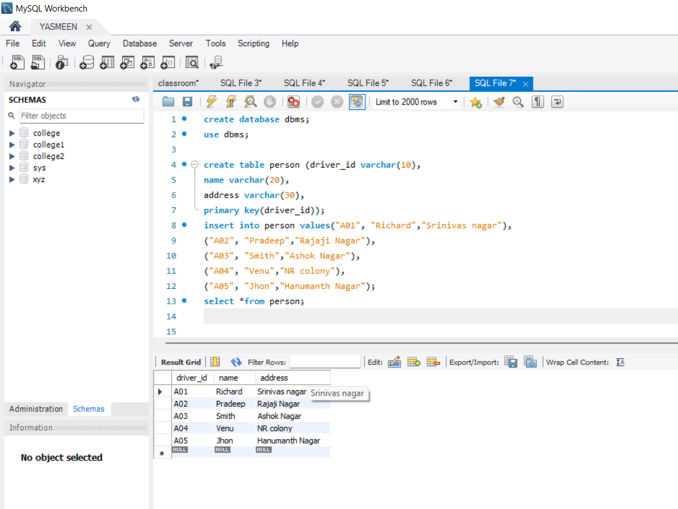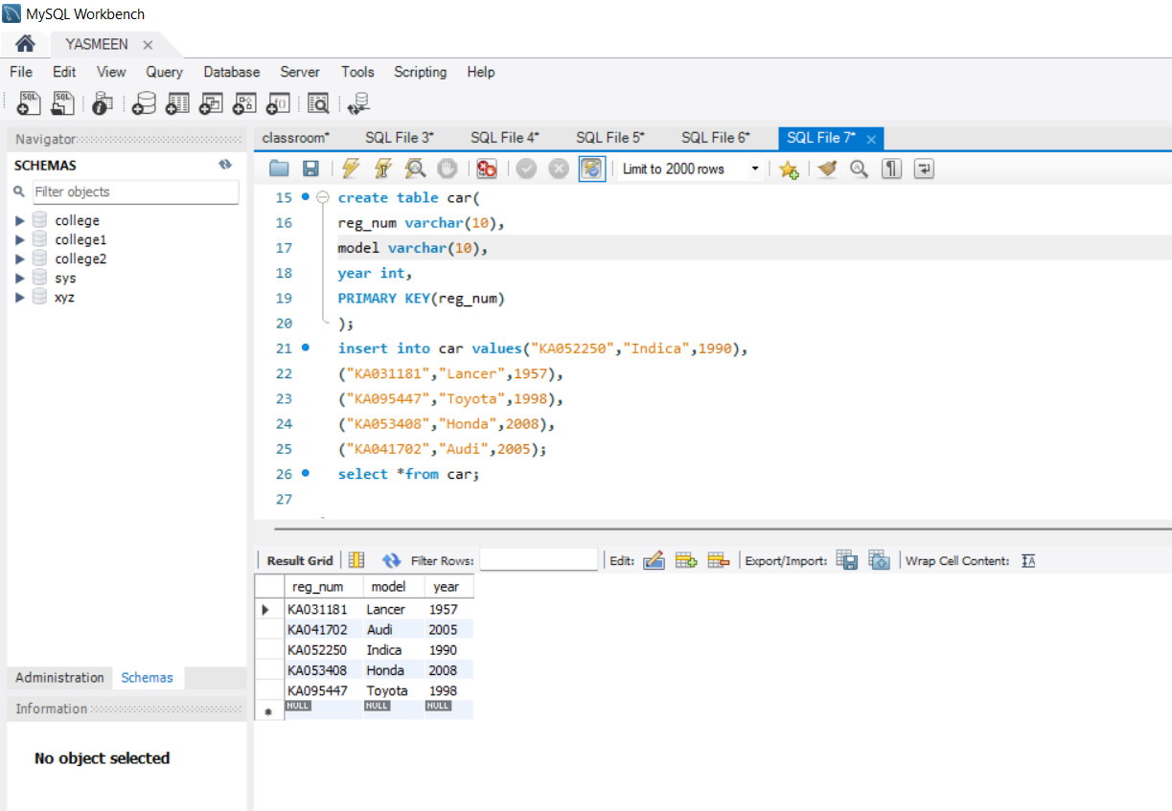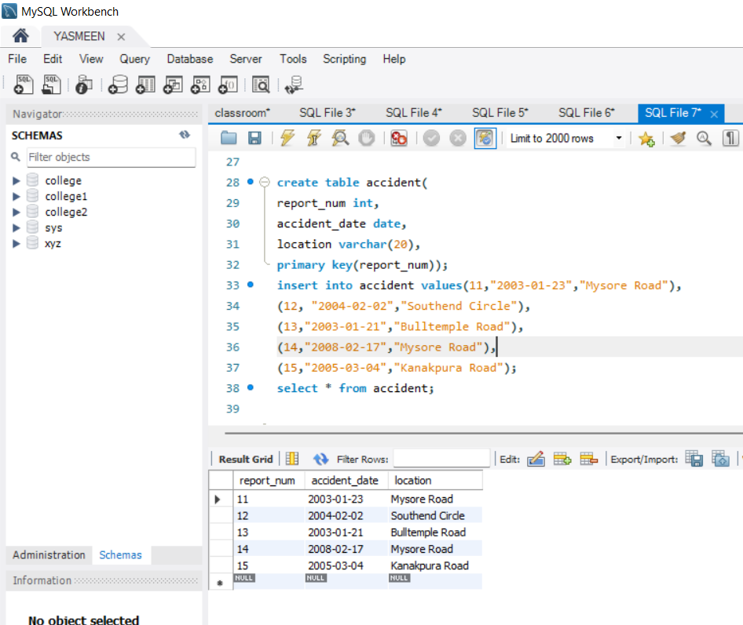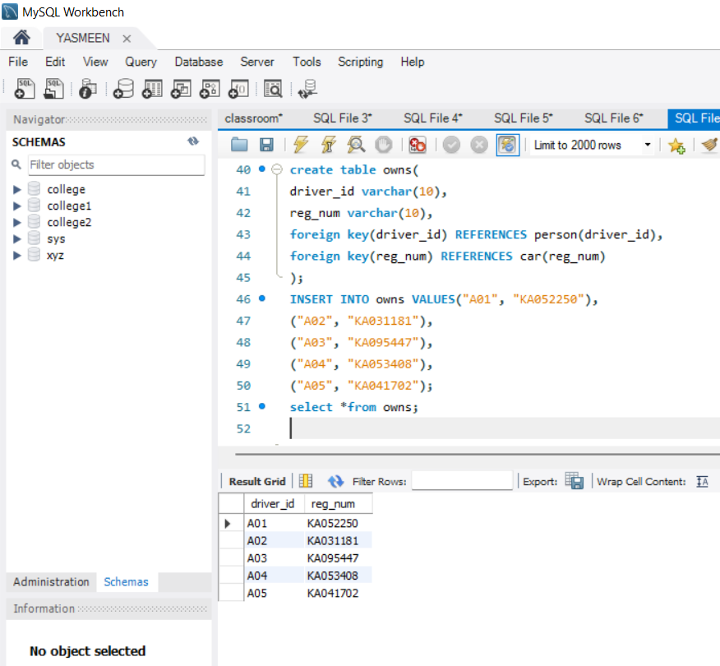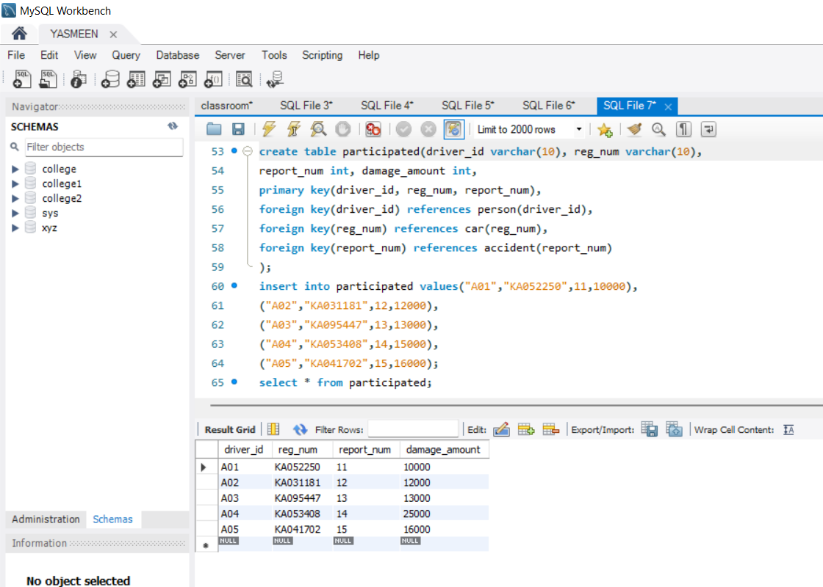

UPDATE THE DAMAGE AMOUNT TO 25000 FOR REPORT NUMBER 14

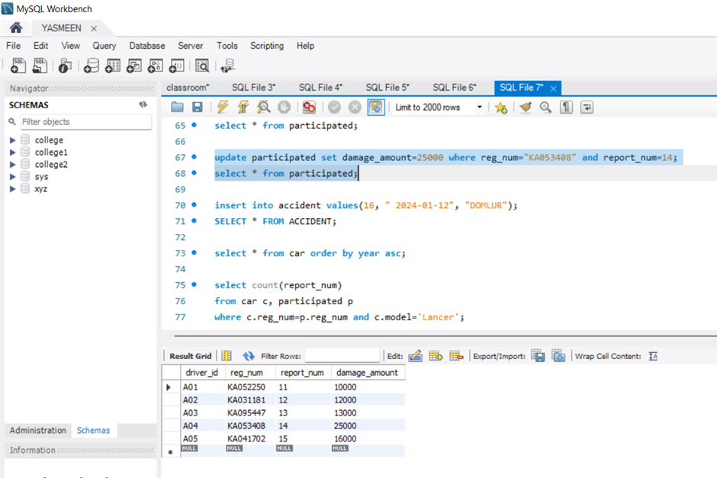

ADD NEW ACCIDENT TO THE DATABASE

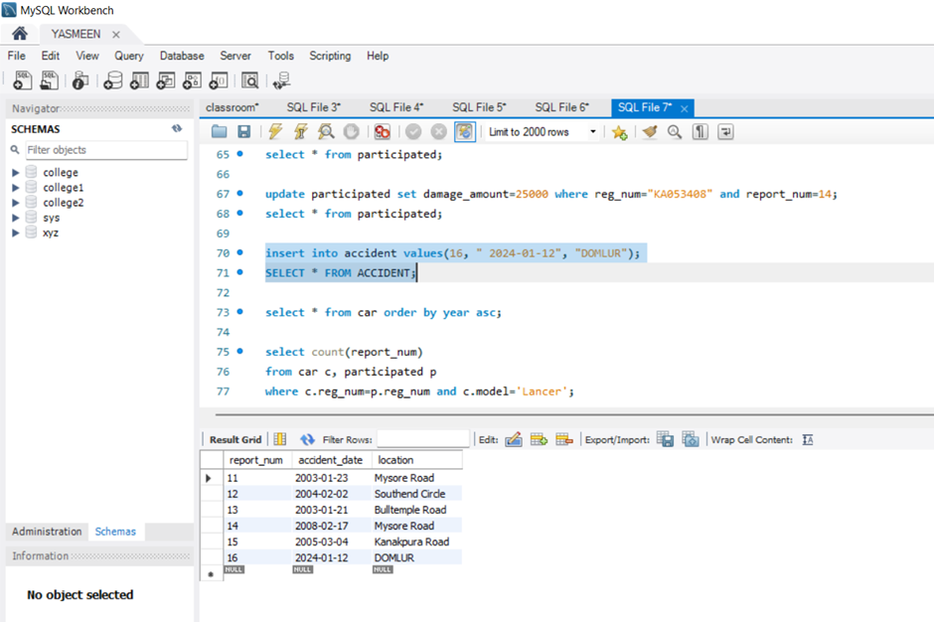

DISPLAY ACCIDENT DATE AND LOCATION

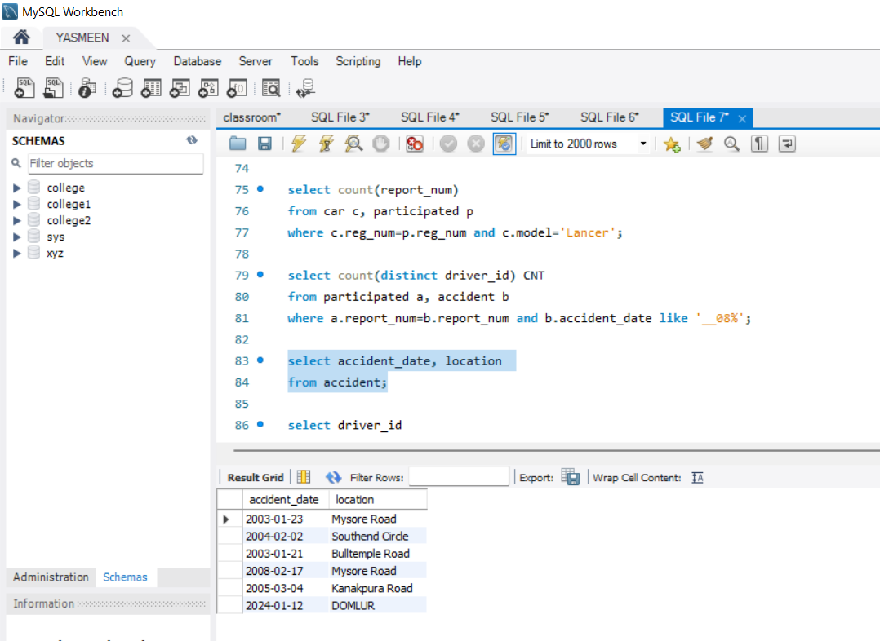

DRIVER ID WHO DID THE DAMAGE AMOUNT GREATER THAN 25000

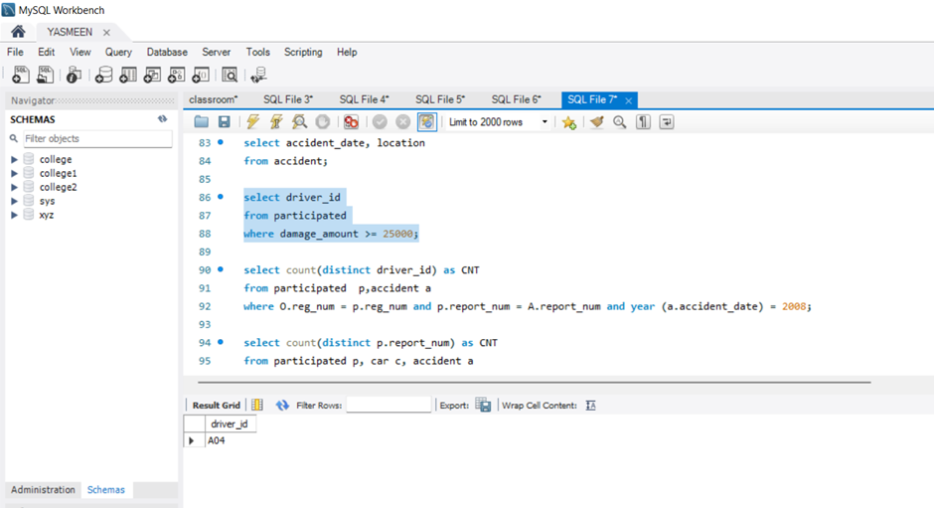

DISPLAY THE ENTIRE CAR IN THE ASCENDING ORDER OF MANUFACTURING ORDER

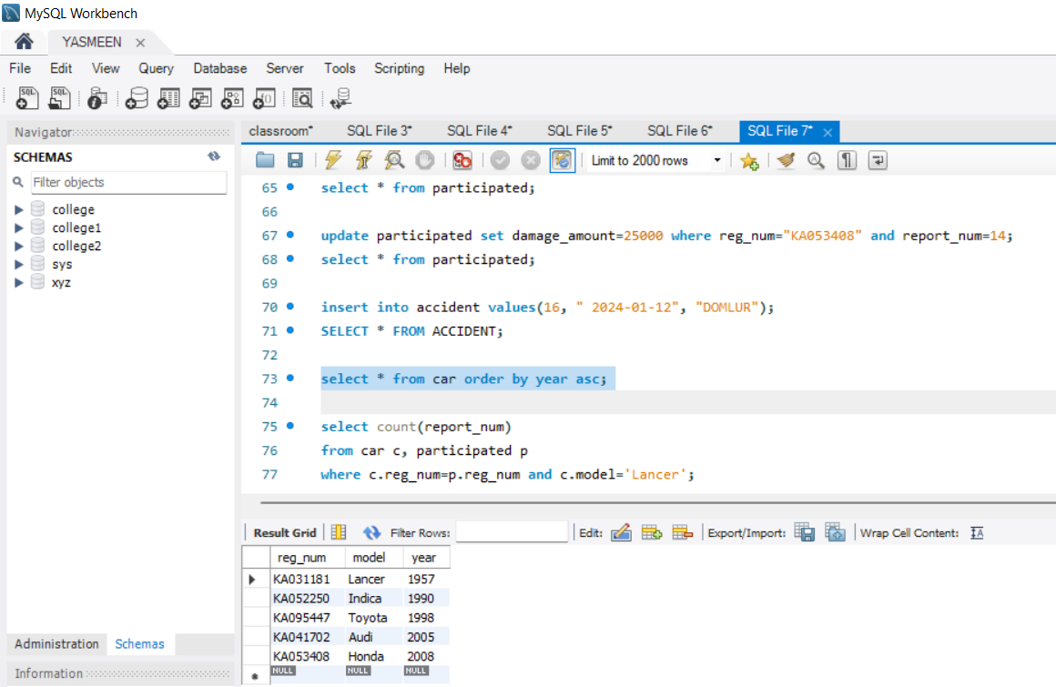

NO OF ACCIDENTS BELONG TO LANCER MODEL

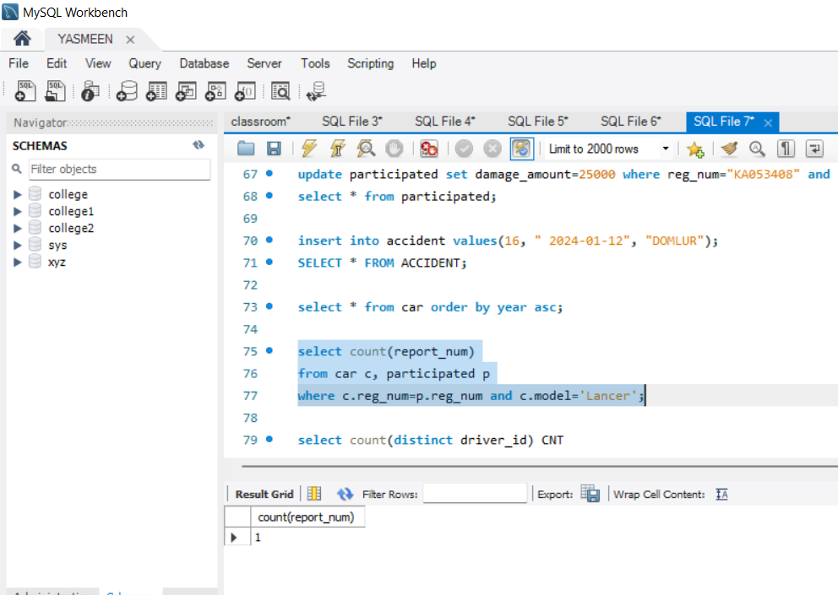

NO OF ACCIDENTS IN 2008

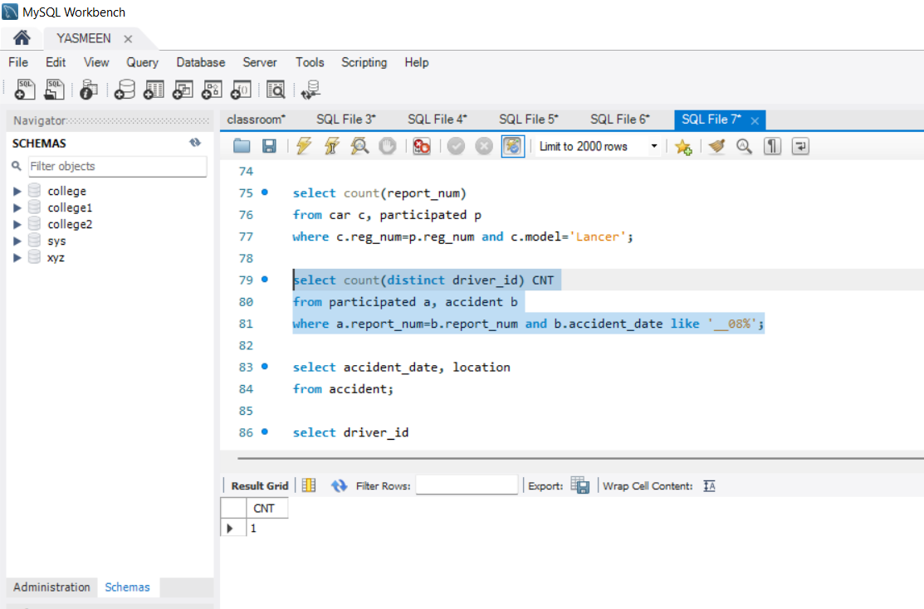

NO OF ACCIDENTS WITH MODEL LANCER AND IN YEAR 2008

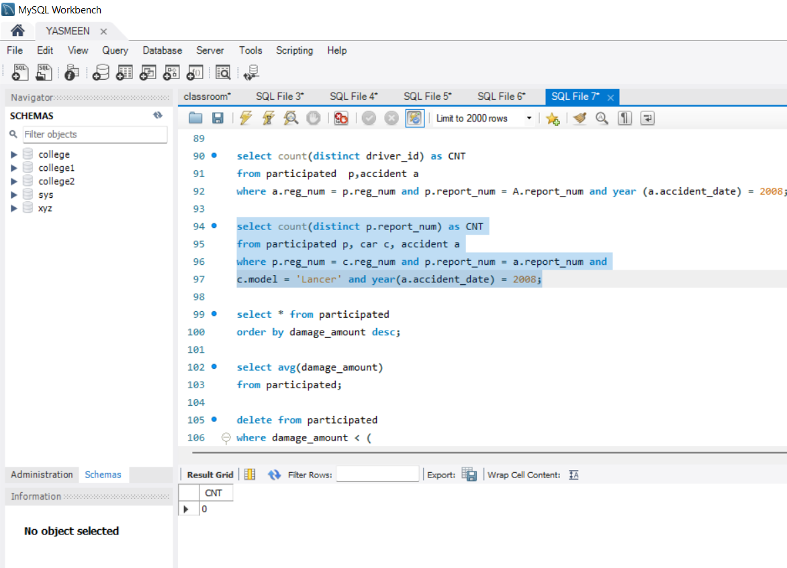

DESCENDING ORDER OF DAMAGE AMOUNT

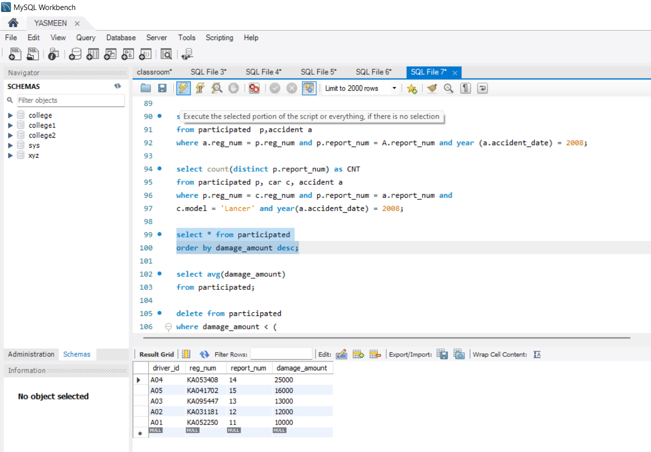

AVERAGE DAMAGE AMOUNT

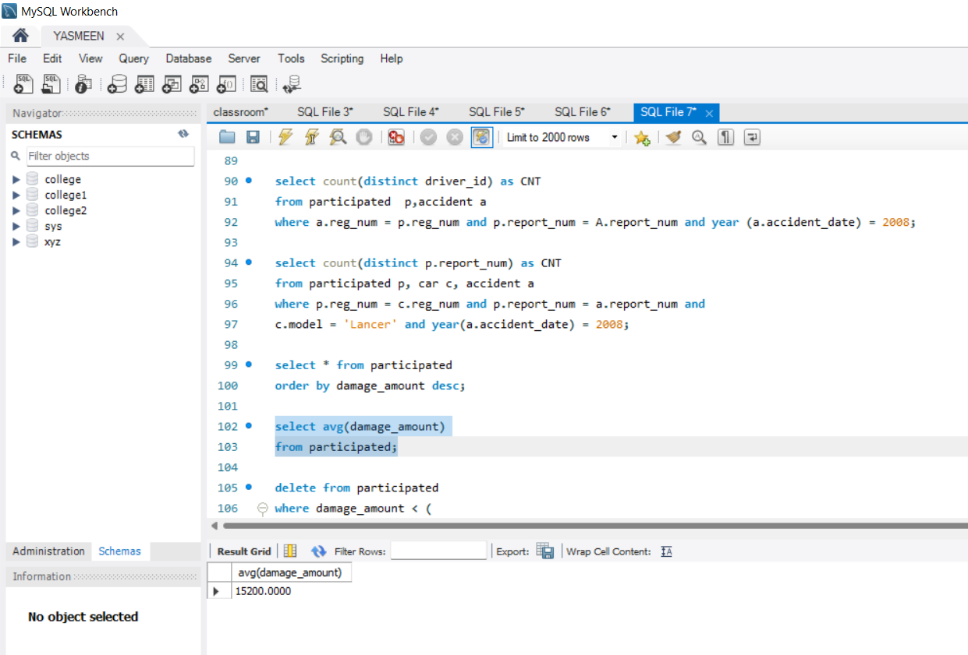

DELETE WHOSE DAMAGE AMOUNT IS LESS THAN AVG DAMAGE

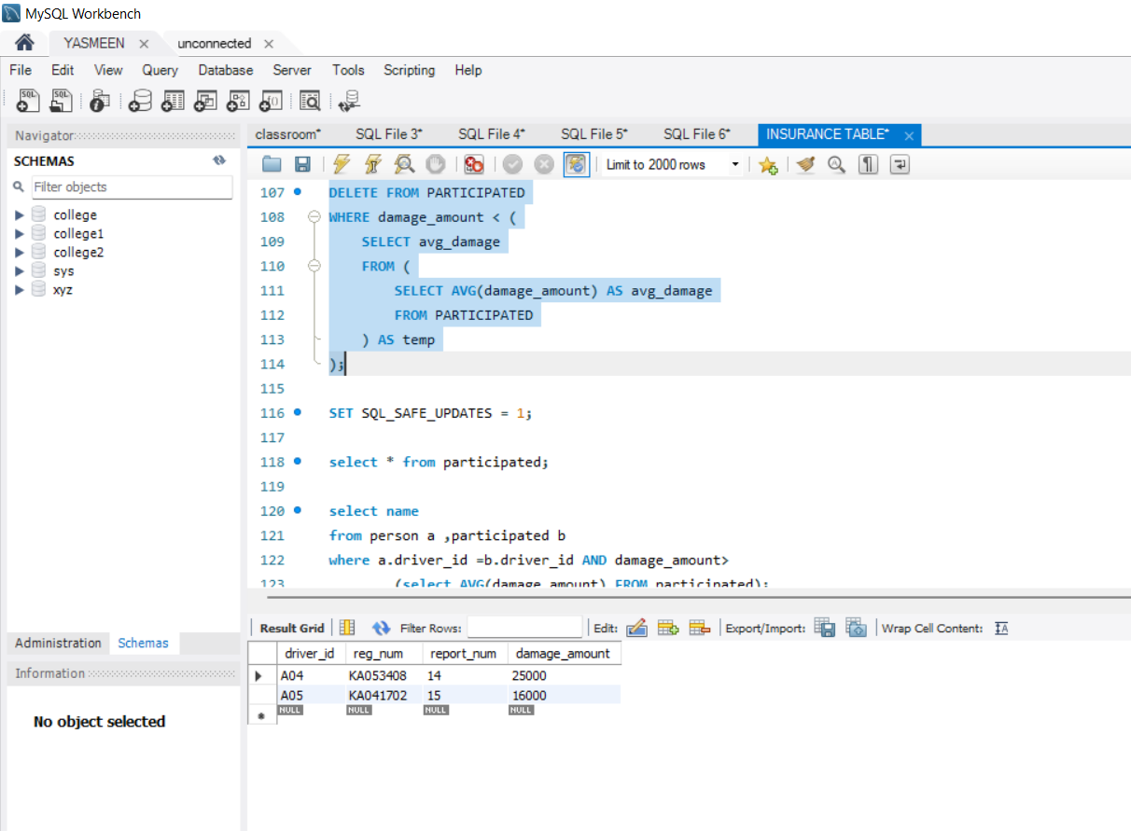

LIST WHOSE DAMAGE AMOUNT IS GREATER THAN AVG DAMAGE

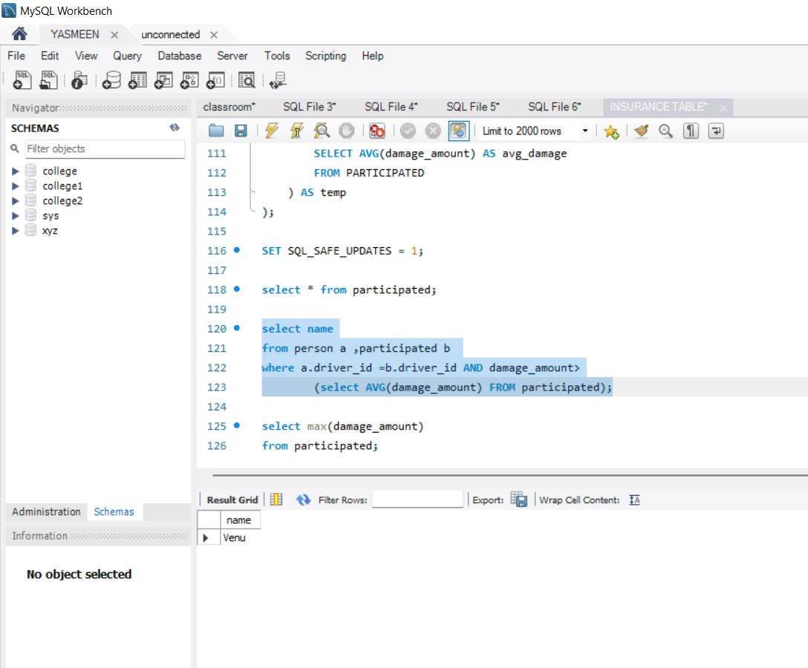

MAX DAMAGE AMOUNT

